

Product Operation Manual
LED Therapy Bed M4N

GUANGZHOU MERICAN OPTOELECTRONIC TECHNOLOGY CO., LTD.

Statement
Thanks for using the LED Therapy Bed-M4N independently developed and produced by Guangzhou Merican Optoelectronic Technology Co., Ltd. ( Hereinafter referred to as “Merican”.)
This manual is a special instruction manual for LED Therapy Bed-M4N of Merican. Any company or people cannot copy and backup this manual by any forms (electronic, mechanical, photocopying, recording or other forms) if without the written permission.
This user manual is only for the operation instructions of the LED Therapy Bed-M4N of Merican. If it is used for the operation of other equipment, the company does not assume any responsibility.
Non- LED therapy bed-M4N itself quality problems: such as the user's abuse, misuse, unauthorized disassembly, repair of the equipment, failure to operate and maintain the equipment in accordance with this manual, loss, etc., equipment failures are not included in the free maintenance.
Manual Instructions
This manual will provide you with relevant rules and precautions for the installation of LED Therapy Bed-M4N, daily operation instructions, after-sales service, etc. Please keep the manual by your side for quick search.
In order to use this series of LED therapy bed correctly, give full play to the excellent performance of the product and ensure the safety of users and equipment, please read this manual carefully before using the machine. Improper use may cause abnormal operation of the LED therapy bed malfunction, shortened service life, and even equipment damage, personal injury or death!
This manual is written based on the existing functions and configurations of the product. If new functions and configurations are added, this manual will be revised accordingly, and the new version of the manual will be mailed to you along with the product.
If there is something unclear, you can contact our company in the following ways:
Company: GUANGZHOU MERICAN OPTOELECTRONIC TECHNOLOGY CO.,LTD
Address: Bldg. A, No.8 Fuyuan 3rd Rd, Huadu District, Guangzhou, China
Website: www.mericanholding.com

Product Introduction
We have always maintained product stability, fashion and durability, and through continuous R&D and innovation, we have enriched product features and functions to design more cost-effective products for customers. Let us look forward to your safe and comfortable experience together!

Product Overview
The MERICAN M4N series has introduced a third-generation bed that is designed like a space capsule full bed. It is equipped with unique light source technology that provides greater irradiation intensity, higher power, and stronger stable output energy. The light can penetrate deeper into your skin, and you can use it safely and comfortably. The bed can reach the best operating state in a short time, providing a great experience to customers. The lower part of the bed has a colorful LED light strip, and the design is such that customers feel like they are in a "time capsule". The internal design is more ergonomic and the height of the bed is suitable for women, making it easy and comfortable for them to move from entering the bed to lying down. You can also turn on the multimedia music function and relax while enjoying the service.

Product Appearance
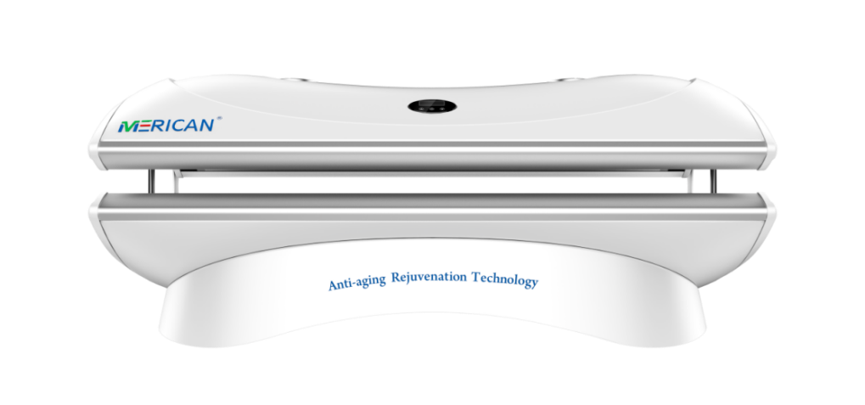
(IMAGE FOR REFERENCE ONLY, ACTUAL PRODUCT SHALL PREVAIL)

Product Features

It adopts a special ratio composite LED light source jointly developed by the Merican Light Energy Research Center and a German team, which is safe, stable, and effective;

Integrated self-circulation cooling system and newly designed heat dissipation holes realize 360-degree all-round heat dissipation, greatly improving comfort;

Scientific and perfect electronic control system with functions of timing, query, memory and remote control;

Originated design, the structure is advanced, compact, and seamless, and the use process is safe, private and comfortable;

The advanced and intelligent fan delay function ensures that the machine will enter the next session after it completely cools down;

Equipped with a surround sound Bluetooth audio system.

The adjustable foot support structure design can adjust the overall height of the bench according to the need to adapt to more scenarios.

Applicable Places
In postpartum rehabilitation institutions, beauty spas, skin management centers, health & wellness center, fitness centers, rehabilitation centers, etc., Merican has a strong technical research and development team, which can also be customized according to your needs. Please consult us for details.

Working Principle

Light that is good for the body
The LED therapy bed uses high-tech nanotechnology pure physical light therapy to emit specific light waves through high-energy semiconductor chips to treat and repair the human body. The red light we promote has been proven by many clinical studies and is known as the "light of life".
The therapeutic mechanism of the LED therapy bed is to produce photochemical effects on biological cells, not thermal effects. Mitochondria in cells absorb the most red lights. After red light is irradiated, the catalase activity of mitochondria increases, which can increase cell metabolism, increase glycogen content, increase protein synthesis and increase the decomposition of adenosine triphosphate, thereby promoting cell synthesis. Speeds up the elimination of sick or dead cells，strengthen cell regeneration, improves blood circulation, and promotes the healing of wounds and ulcers; At the same time, it also enhances the phagocytic ability of white blood cells, thereby achieving anti-inflammatory, analgesic, and improving immune function of the body; it is beneficial to wound healing, Fracture healing, and nerve repair, etc.

Product Efficacy
- Relieve cardiovascular and cerebrovascular diseases: Led therapy has a warming effect on the skin and mucous membranes, dilates blood vessels in deeper tissues, improves blood circulation, purifies the blood, and can prevent or alleviate cardiovascular and cerebrovascular diseases such as myocardial infarction and brain Infarction, coronary heart disease, hypertension, hyperlipidemia, hyperglycemia, etc.
- Improve pain: It can increase the catalase activity of cell mitochondria, promote the solidification of diseased tissue proteins and the production of new squamous epithelial cells, accelerate the absorption of exudates, weaken muscle tension, and improve various nerves, Tissue, and joint pain, dysmenorrhea, gout, sports injuries, and other pains.
- Promote the dissipation of inflammation: it can promote local blood circulation, increase the phagocytic function of cells and macrophages, control infections, and promote the dissipation of inflammation, such as: chronic inflammation, such as neurodermatitis, eczema, chronic lymphadenitis, etc., and various Causes of osteoarthritis, such as senile osteoarthritis, rheumatoid arthritis, etc.
- Promote wound healing: It can improve blood circulation, promote wound regeneration and repair, to achieve pain relief, reduce swelling, promote granulation tissue growth, shorten wound healing time, reduce postoperative adhesions, promote scar softening, and reduce scar contracture.
- Enhance physical fitness: It can increase the catalase activity of mitochondria, thereby increasing glycogen content, protein synthesis, and adenosine triphosphate decomposition, enhancing cell viability, and enhancing the body's self-repair function and cell regeneration ability.
- Relieve acne: It can promote skin blood circulation, enhance the vitality of human cells, enhance metabolism, speed up the elimination of sick or dead cells, and can alleviate and fade facial acne (acne), freckles, scars, postpartum stretch marks, etc..
- Skin lightening and spot-lightening: It acts on the skin through broad-spectrum strengthening and promotes the production of fibroblasts, so that the pigment cells are swallowed, so that the skin tone will gradually become fairer, and the originally dull skin will also become irradiated by the red light. Transparent, exudes a bright luster.
- Wrinkle removal and skin rejuvenation: stimulate the production of collagen, increase skin elasticity, smooth wrinkles, shrink pores, and make skin firm, smooth and delicate.
- Improve sleep: It can adjust the autonomic nerves to maintain a good state, effectively improve or eliminate headaches, dizziness, cold limbs, etc., improve sleep, and improve sleep quality.

Unsuitable People
- Pregnant women, customers with cardiac pacemakers, and patients with malignant tumors.
- Customers who are allergic to photos or who take photosensitizers (such as chlorpromazine).
- Customers with active hemorrhage or shock, and internal organ damage.
- Customers with high fever, active tuberculosis, vasculitis obliterans, etc.
- Patients with severe heart and kidney disease, such as heart failure, myocarditis, uremia, etc.

Precautions for Use
- It is recommended to irradiate naked, and all accessories and cosmetics must be removed from the whole body.
- Pay attention to eye protection during use. Please remove contact lenses during use, and special eye protection (eye patch) must be worn.
- The use time should be set by a special person according to the suggestion of the physical therapist. Do not adjust the irradiation time at will during use.
- Under normal circumstances, each use should not exceed 30 minutes.
- Pay attention to the user's reaction during use, such as overheating, palpitation, dizziness, etc., and contact the staff immediately.
- If there is a wound, the wound should be debrided before use, and fresh scars should be used with caution.
- After the first use, observe whether there is any red light allergic reaction. If not, continue to follow the course of treatment.
- It cannot be used to treat congenital skin hypoplasia, such as warts, spots, and moles.

Product Parameter
Product Model | M4N | M4N Plus
Light Source | Taiwan LED light source
LED Qty. | 10800pcs | 21600pcs
Heat Abstractor | Forced air cooling system with 9 fans (Upper 2 fans, lower 7 fans)
Structure | Horizontal, full cabin, hydraulic rod, cooling device
Control System | Smart Control System 2.2,  (Optional External Controller)
Power Supply | 110V | 220V
Current (220V) | 7A | 15A
Output Power | 1500W | 3000W
Product Size | 1940*860*820mm - Inner height: 338mm
Product Weight | 120kg

Product Installation
  - Unpacking Inspection
Please check if the packaging is intact before unpacking. After unpacking, take out the parts, please check the following items:
- Confirm that there is no damage to the machine during transportation, and check that the appearance of the machine is not damaged or notched;
- Confirm that the packing box has an instruction manual and a warranty card (the warranty card is on the last page of this manual);
- Check whether the machine nameplate information is consistent with the ordered product;
- If you have ordered accessories, confirm that the received accessories are what you need.
Warning: Do not install or operate any Led therapy bed that is damaged or has faulty parts, otherwise there is a danger of injury.
If you find any questions, please get in touch with Merican and solve them immediately.

Product Installation Specifications
- The machine must be grounded correctly before using. When multiple machines are grounded, it is recommended that you do not use a common ground wire to avoid the ground wire forming a loop;
- In order to prolong the service life of the lamp and the machine, please turn off the power in time when not in use;
- After the main power switch is turned off, you must wait at least 3 minutes for the machine to cool down completely before allowing installation/ disassembly operations;
- It is forbidden to install and debug under non-insulated conditions to avoid electric shock;
- The indoor air must be kept unblocked, and the distance between the outer edge of the machine and the wall is not less than 30cm;
- Please refer to the description of this manual for the installation and use environment of this machine. Failure to meet the environmental requirements may reduce the service life of the machine or even cause damage.

Product Safety Requirements
- The safety and correctness of the machine can only be guaranteed when it is connected with the machine provided by the company, and the safety of the equipment provided by any other company cannot be guaranteed;
- In order to prevent circuit danger, the machine can only be connected to a power socket with protective grounding. If the power socket is not connected to a grounding wire, or the integrity of the protective grounding wire is questioned, please do not use the socket;
- When a sudden power failure occurs during the normal use of the machine, the machine will not cause damage to the operator or user. Please turn off the power switch first, and perform normal operation according to the instructions when the power is turned on again;
- Do not open the casing of the machine by yourself; otherwise there may be a risk of electric shock. The maintenance or upgrade of the machine must be carried out by maintenance personnel trained or authorized by the company;
- In order to prevent electric shock and reduce machine failure, the machine must not be flooded. If the machine is accidentally exposed to water, please stop using it immediately and hand it over to professional technicians before using it again;
- Before using the machine, check the machine and its connecting cables and accessories carefully to ensure that they can work normally and safely;
- Use according to the parameters specified by our company;
- In order to ensure the safe operation of the machine, all kinds of replaceable parts, accessories and various consumables equipped with the machine please use the products provided or designated by our company;
- During using, use hypochlorous acid disinfection water/75% alcohol to clean and keep the surface of the bed clean. Generally, wipe with hypochlorous acid disinfection water/75% alcohol once a week.

Technical Specifications
Project |  | Description
Control Characteristics | Start time | <3 seconds
Control Characteristics | Operation control | Control system operation panel
Control Characteristics | Modulation method | Physical touch screen
Control Characteristics | Environment Temperature | 15°C~35°C
Ambient | Environmental humidity | ≦75%RH, without condensation
Ambient | Degree of protection | IP 53
Structure | Cooling method | Forced air cooling
Structure | Installation method | Vertical installation

Installation Requirements
This machine needs to be installed indoors. During installation, there is no obstruction within 1 meter around the machine to ensure well heat dissipation.

Temperature and Humidity
- The ambient temperature must be between 15°C and 35°C;
- The relative humidity of the air is less than or equal to 75%RH, without condensation.

Other Installation Environment Requirements
- Install in a place that is unlikely to be subjected to severe vibration and impact;
- Install in a place where metal powder, dust, oil, water, etc. cannot penetrate into the machine;
- Avoid installing in places with oil mist, steam, or salt;
- Avoid installing in places directly exposed to the sun;
- Avoid installing in dusty or metal powder places;
- It is strictly forbidden to install in places with flammable and explosive materials such as anesthetics.
Note: If there are special installation environment requirements, please consult and confirm in advance.

Installation Interval and Distance Requirements
- The min distance between the four sides of a machine and the wall (30cm).
- The min distance between two machines (100cm).

Electrical Configuration Requirements

The MERICAN M4N series is equipped with a 16A leakage protection plug.

Product Installation
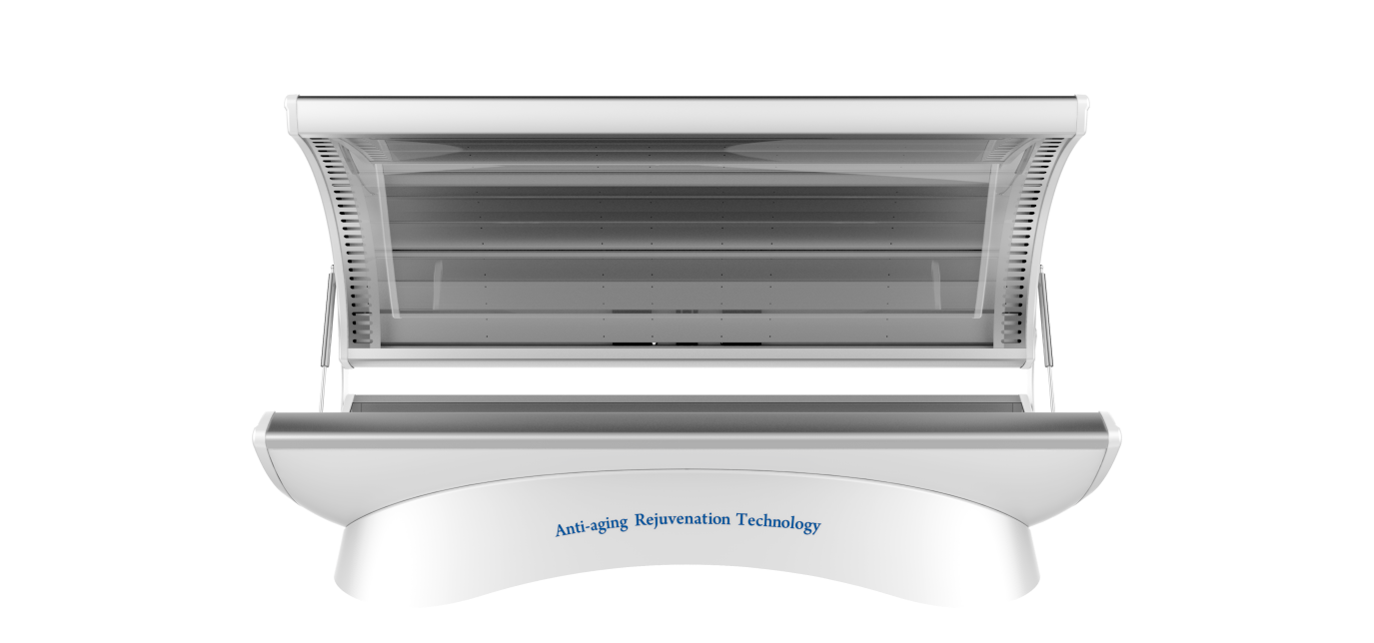
(IMAGE FOR REFERENCE ONLY, ACTUAL PRODUCT SHALL PREVAIL)

Disassembled
The M4N LED therapy bed is delivered as a completed machine. After opening the package, it can be used after wiring according to this manual.
If necessary, the machine can be disassembled and moved indoors. Please contact the seller to get the guiding. It’s strongly to disassemble by technician.

Name of each parts
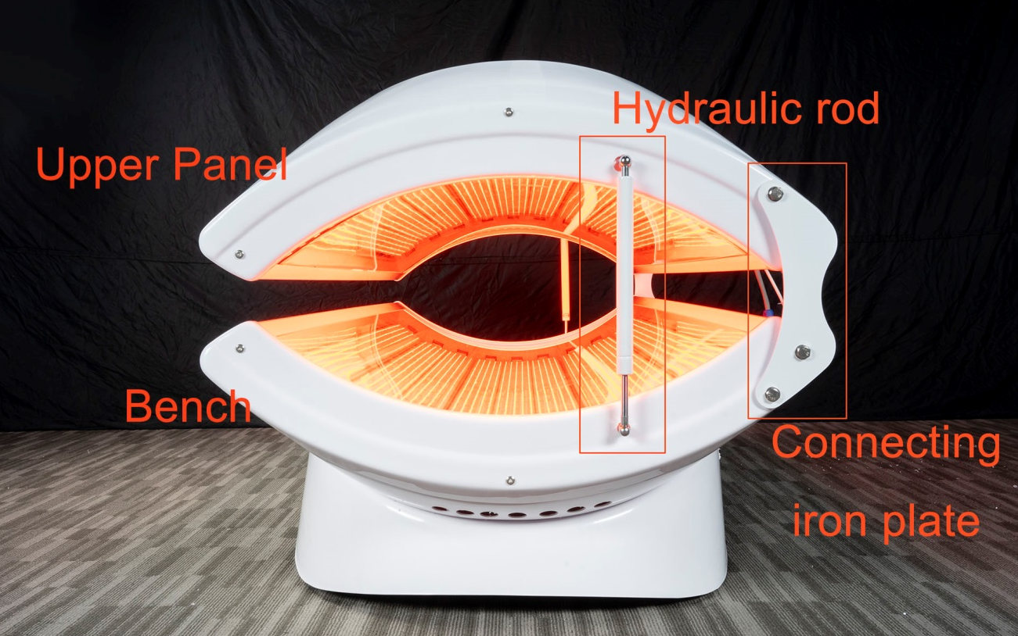

Assemble
- Lay the bench of the machine flat, align the two holes in the lower part of the iron plate with the corresponding screw holes in the bench, and tighten the screws. The left and right sides are the same. Install one side first, and then the other side.
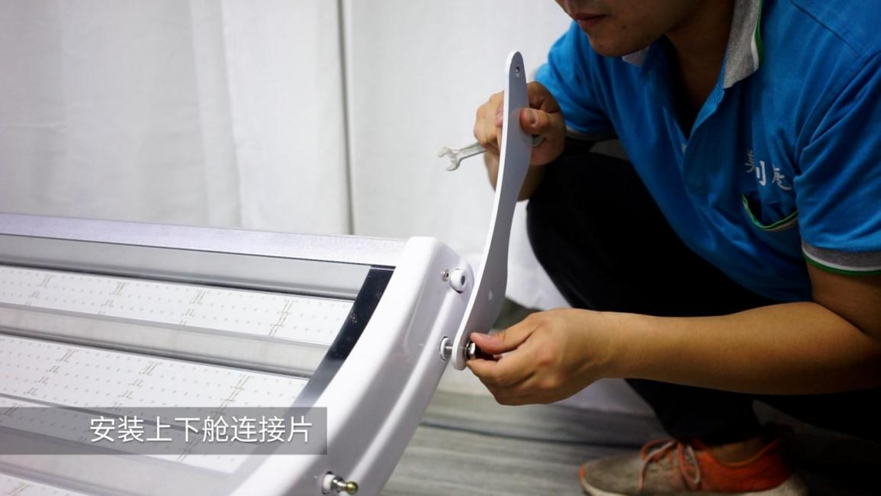
Install connecting iron plate
- Lift the canopy over the bench, align the screw holes of the upper and bench connecting iron plate, and on both sides. Install one side first, and then the other side.
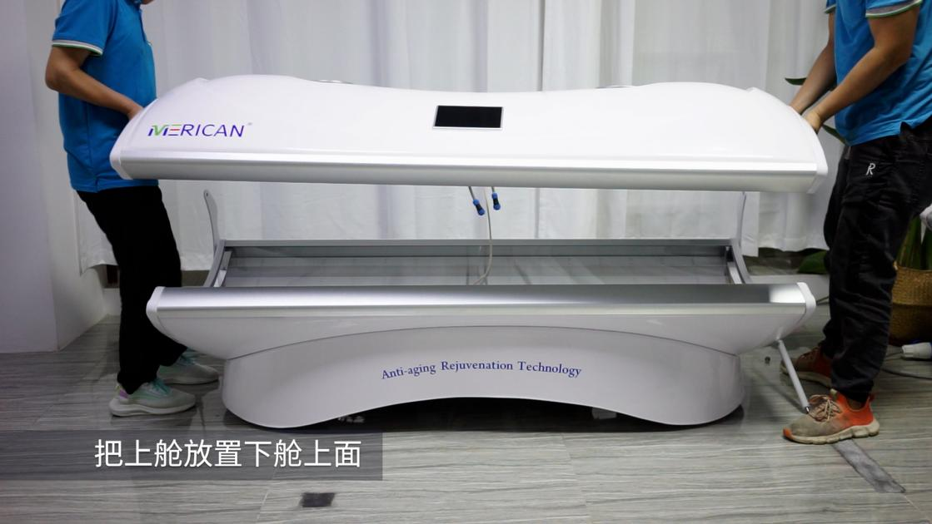
Lift the canopy over the bench
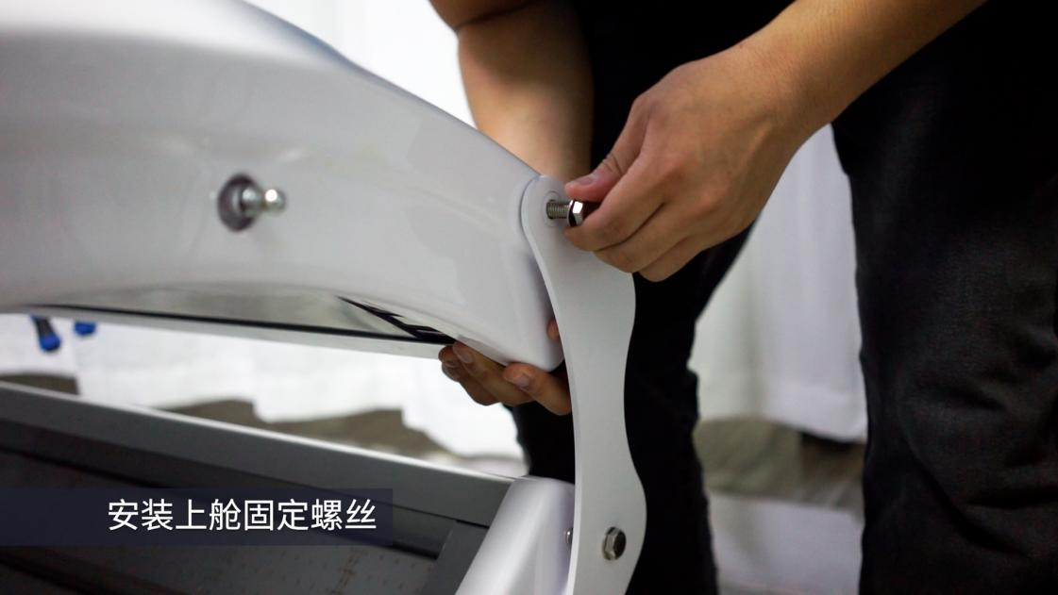
Tighten the screws
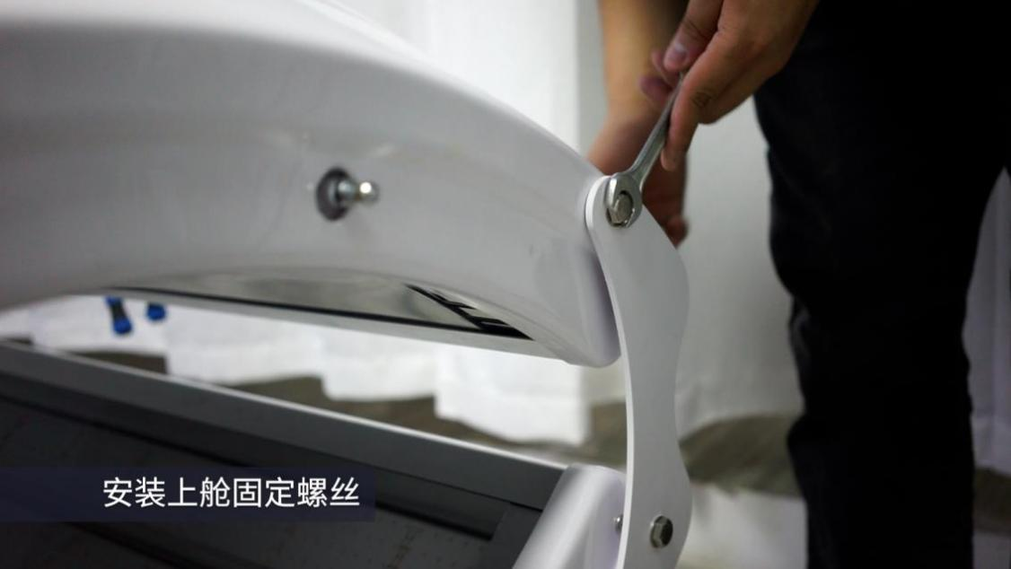
Tighten the screws
- After tightening the nut on the connecting iron plates of the canopy and bench, open the canopy to the maximum, and then tighten the nut of the . If the nut of the hydraulic rod is not aligned, press the hydraulic rod with your hand, and press continuously.
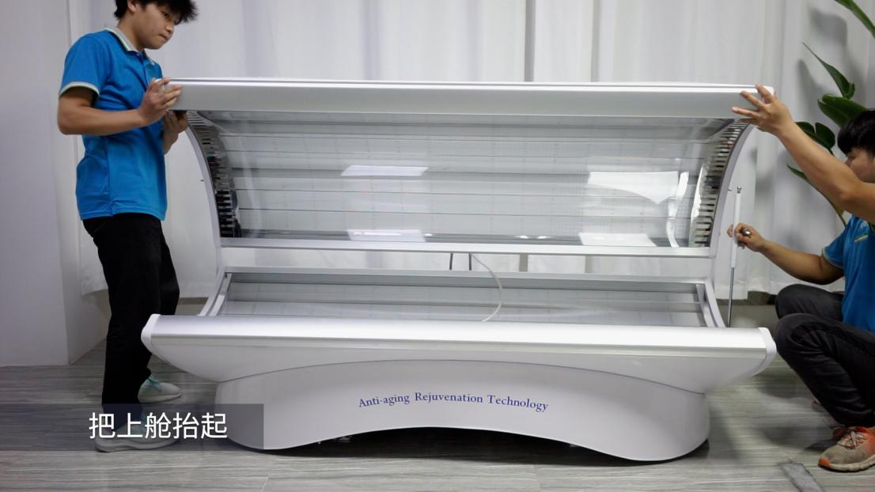
Lift the canopy
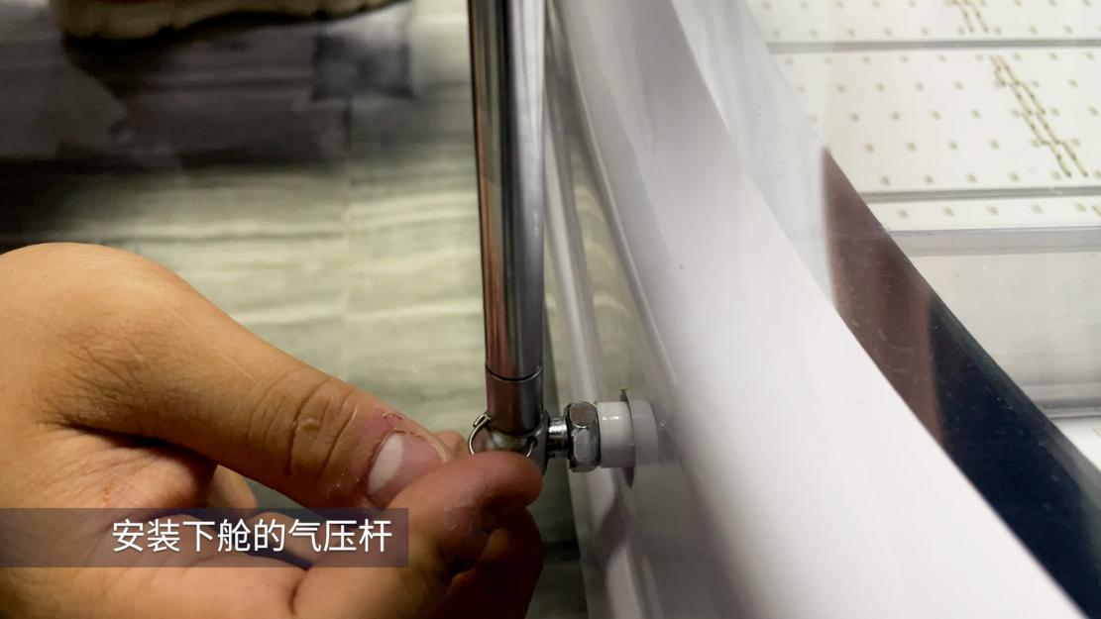
Install the hydraulic rod
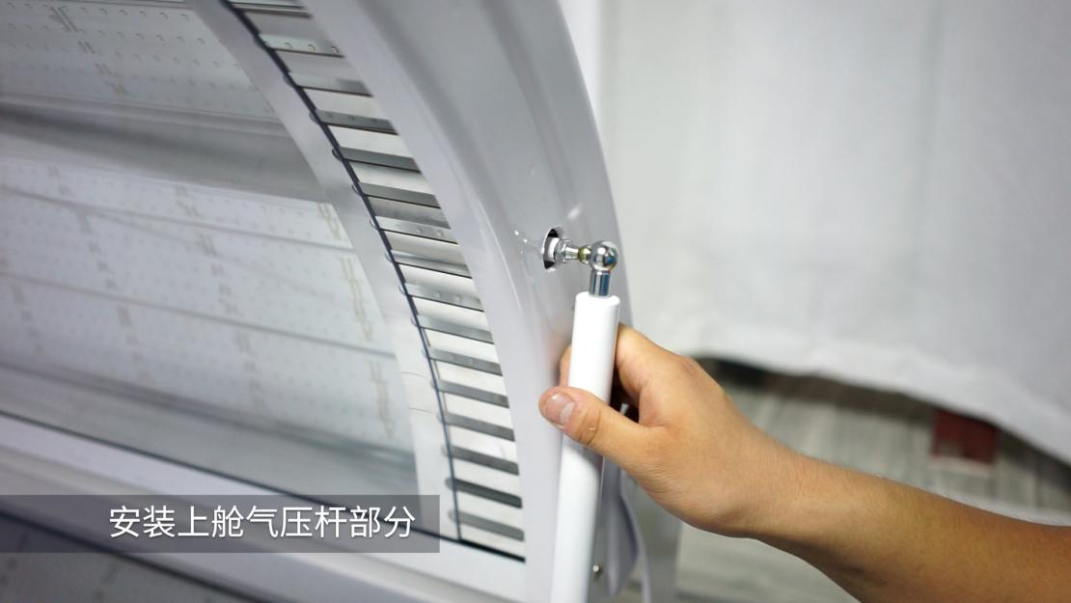
Install the hydraulic rod

- Align the canopy and bench connecting wires and plug them tightly. The white one is the canopy light control line, and the black one is the audio line.
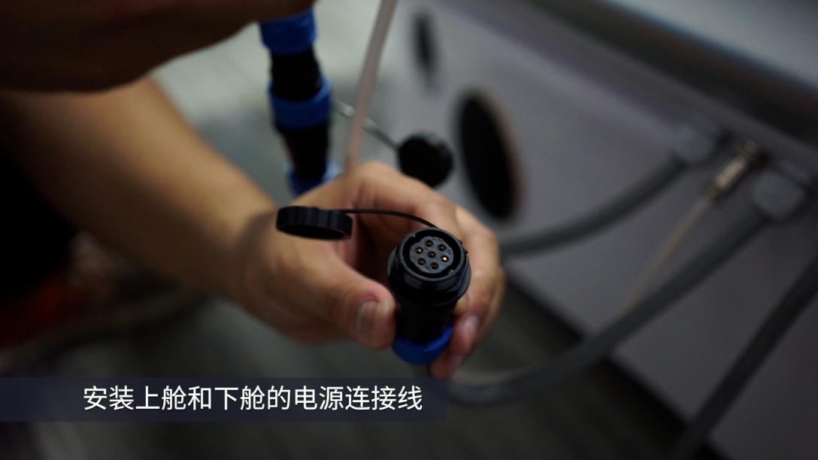
Align the canopy and bench connecting wires and plug them tightly
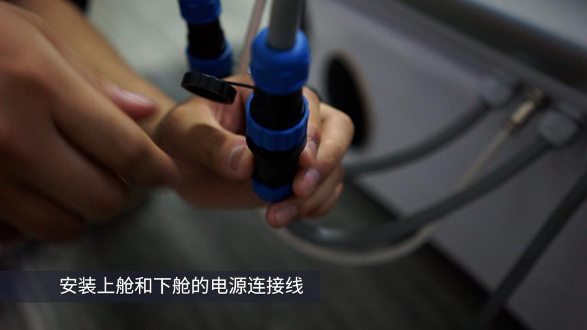
Align the canopy and bench connecting wires and plug them tightly

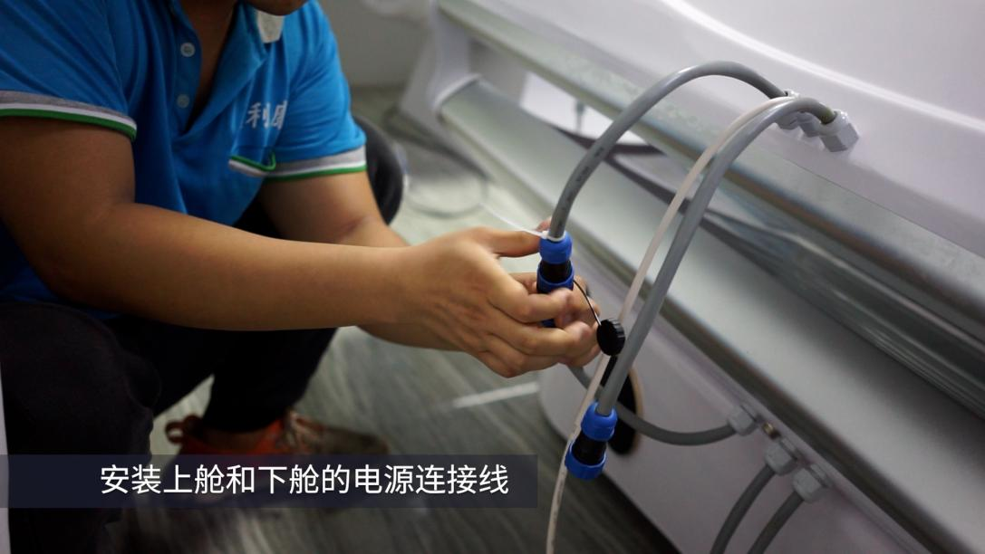
Align the canopy and bench connecting wires and plug them tightly

Product use and operation
Please read the operating instructions carefully before using the M4 LED therapy bed, and operate in strict accordance with the operating instructions.
3.1 Main page
After the device is powered on, the main page will appear, as shown in the image below.
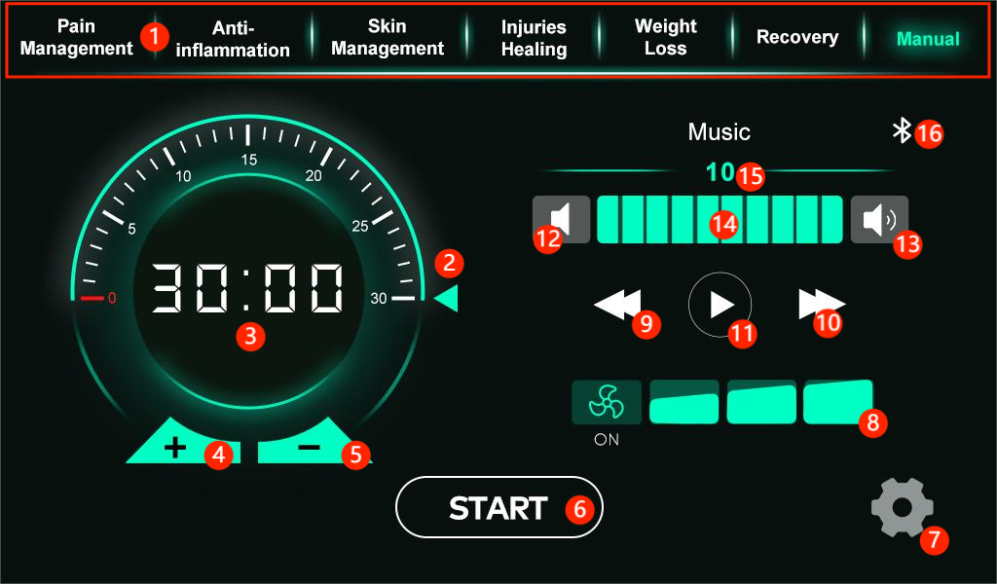
Numbers on the page are as follows:
- The preset protocol selection includes 6 preset protocol and 1 manual setting. To use, click the desired preset protocol.
- Adjust the time(method 1) , which can be adjusted by sliding a slider, with one increment representing one minute. The adjustable time is 0-30 minutes.
- The time display shows the currently set working time when adjusting the time, and the remaining working time (countdown) when working. When not start the machine, only minutes are displayed 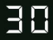; when start the machine, minutes and seconds are displayed .
- Adjusting the time(method 2) : Increase the time. A single tap increases the time by one minute; a long press continues to increase . The time cannot be adjusted after starting work. Adjustable time ranges from 1 to 30 minutes.
- Adjust the time (method 2) : Decrease the time. A single tap decreases the time by one minute; a long press continues to decrease . The time cannot be adjusted after starting work. Adjustable time ranges from 1 to 30 minutes.
- The machine operation control button,start the equipment .
Pause /Resume 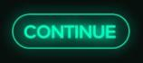. After starting working, press this button for 2 seconds to stop working. Operation is free when not connected to the app. Once connected to the app, you must click (START) on the app's homepage to operate the system ; otherwise, it cannot be started . When the temperature exceeds the alarm temperature by 5 degrees Celsius, this button will turn gray and become inoperable. The light will also turn off automatically, requiring heat dissipation. When the temperature drops below the alarm temperature by 5degrees Celsius this button will turn green, and the machine can be operated normally.
- Click the "Setting" button to access the backend.
- Fan settings . The icon shows OFF when the fan is off . When the fan is on, the icon shows ON , and the fan speed can be adjusted to the right of the icon .(Wind speeds 1-3)
- Previous song.
- Next song .
- Music play/pause .
- Decrease the volume .
- Increase the volume .
- The volume bar can be dragged to adjust the volume.
- Current volume
- Bluetooth switch. Bluetooth off, Bluetooth on (not connected), Bluetooth on (connected). Note: Please wait 0.5 seconds when turning Bluetooth off/on.
3.2 Wi- Fi configuration page
Click the "Setting" button on the main page to enter the backend .
Wi -Fi configuration page is shown in the image below:
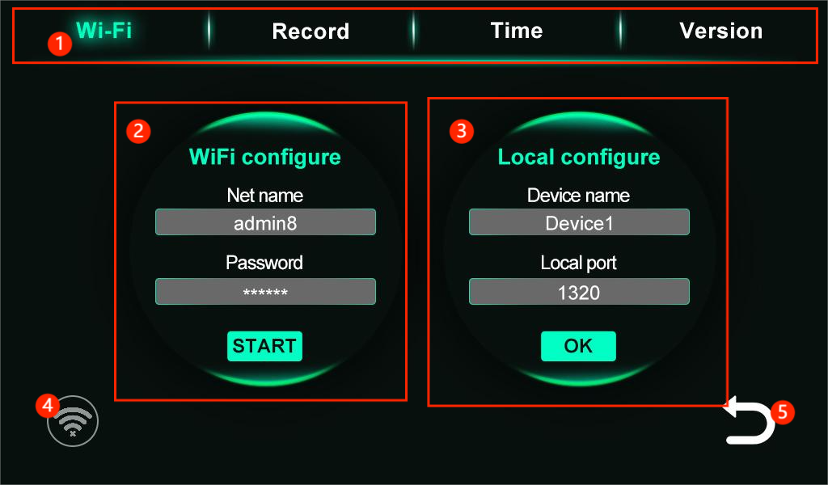
Numbers on the page are as follows:
- Backend function page selection
- Wi - Fi Configure. Click the Net name edit box. In the pop-up Select network page, select the network name you want to connect to, and enter the corresponding password in the Password edit box. Press the START button to reconfigure the Wi- Fi network. The system will save the passwords for the nine most recently connected network names. If the Password edit box is not empty after selecting a network name, it means that you have already connected to that network. In this case, you do not need to enter a password; just press the START button to configure the Wi- Fi network ( this configuration is used to connect to a wireless tablet ) .
- Local configure. You can modify the device name (which is also the Bluetooth name ) in the Device name edit box , and modify the local UDP broadcast receive port in the Local port edit box. This port must be consistent with the UDP broadcast port set on the APP to connect to the corresponding APP ( the manufacturer will set it before leaving the factory, and you do not need to change this port number after receiving the device ) .
- WIFI connection icon
The wireless connection indicator has the following 7 status:
- This indicates that the network is not connected.
- This indicates that the device is connected to the network but not to the app, indicating a weak signal.
- This indicates that the device is connected to the network but not to the app, and the signal is weak.
- It indicates that the device is connected to the network but not to the app, and the signal is very strong.
- This indicates that the device is connected to the network and the app, but the signal is weak.
- This indicates that the device is connected to the network and the app, but the signal strength is average.
- This indicates that the device is connected to the network and the app is connected, and the signal is strong.
- Return to main page

3.3 Usage records
The usage record page is shown in the image below:
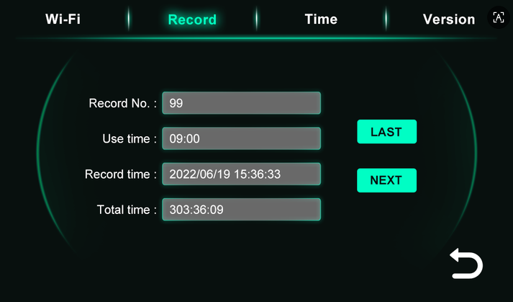
As shown in the image above, this page allows you to view the most recent 999 usage records. Press Last to view the previous record , and Next to view the next record.

3.4 Time settings page
The time settings page is shown in the image below:
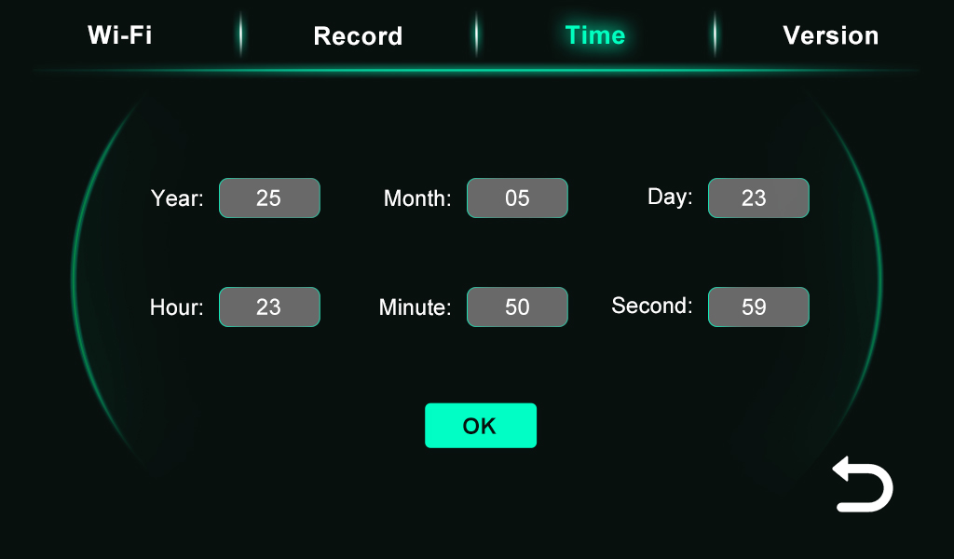
After entering the correct time on this page, press the "OK " button to set the time .

3.5 Version page
The version page is shown in the image below:
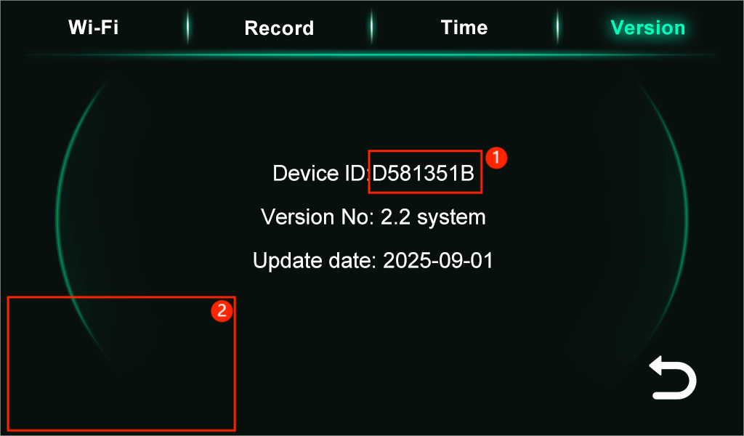
- Machine system number.
- The temperature control interface has a hidden button; press it for 5 seconds to enter the temperature control page.

3.6 Temperature control page
The fan settings page is shown in the image below:
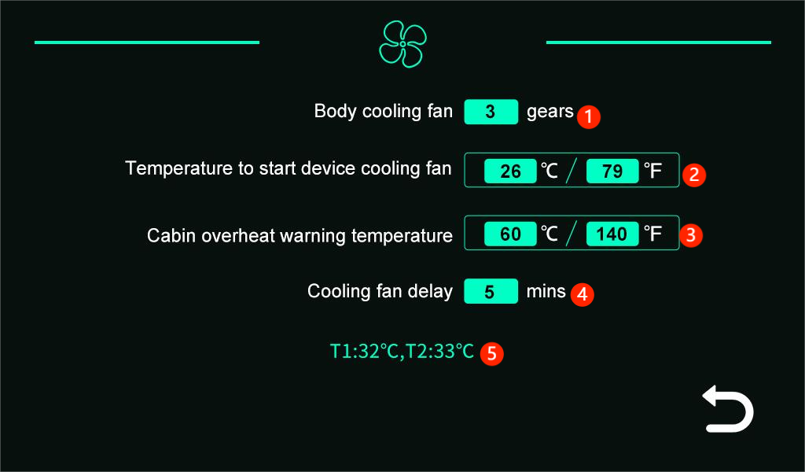
Numners on the page are as follows:
- The human body fan has three speed settings , adjustable from 1 to 3.
- The startup temperature of the machine's cooling fan.(When the working temperature in the machine reaches the set temperature, the cooling fans of machine will start to work)
3.Machine overheat warning temperature setting.The system will display an "Excess temperature of the machine!" alarm message if it detects that the temperature reached this set overheat alarm temperature.
- The delay time for the cooling fan to turn off after work is completed.
- Current temperature

3.7 Preset protocol settings page
Long press this button on the main page to enter setting page.
The protocol page is shown in the image below:
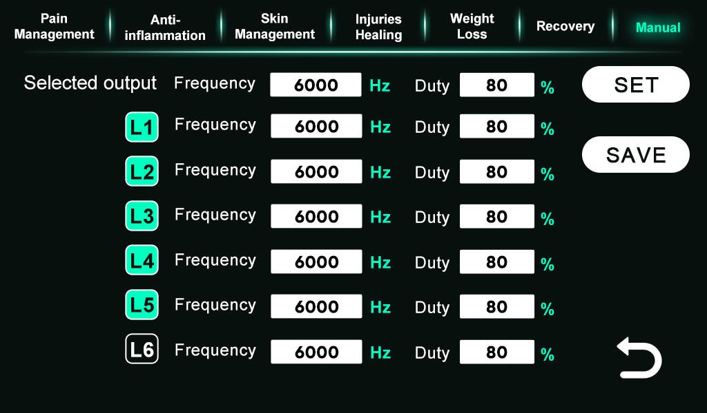
Click on the corresponding preset protocol name, and then configure each preset protocol.
L1-L6 represent different wavelengths. The standard settings are L1=633nm, L2=660nm, L3=810nm, L4=850nm, and L5=940nm. (The specific wavelength configuration of the machine needs to be confirmed with the supplier.)
Click L1-L6 to select/deselect the wavelength. indicates that this wavelength is selected , and indicates that this wavelength is not selected.
There are two ways to set the frequency and duty of the wavelength.
- On the right side of the selected wavelength, set the the frequency and duty for this wavelength individually.


(2) Select the wavelength for which you need to set the frequency and duty, and then set the frequency and duty in the Selected output column. After setting, click SET to complete the setting of the frequency and duty of the selected wavelength (the frequency and duty of the selected wavelength will be consistent).
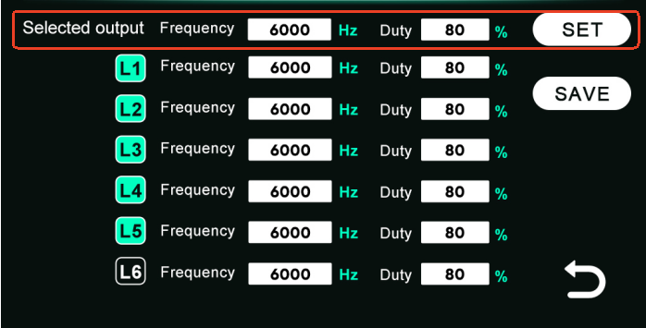
After setting the frequency and duty for the wavelength, press "SAVE" to save the settings to the corresponding preset protocol .
PS: When duty = 100%, there is no pulse frequency,that is Continuous Wave(CW). Only when duty < 100% will there be a pulse frequency,that is pluse light.

3.8 Bluetooth music system connection
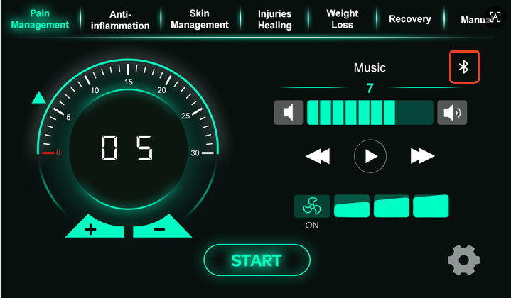
Clicking the Bluetooth button on the main page. indicates that Bluetooth is enabled (not connected), indicates that Bluetooth is connected. Once Bluetooth is connected, other devices cannot search for this machine's Bluetooth.
After enabling Bluetooth, click the setting button on the main page to enter the background and Wi-Fi settings page,view the Bluetooth name (Device name). Then open your phone's Bluetooth settings, search for the machine's Bluetooth name, and connect.

3.9 Tablet app connection (optional; if you don't have a tablet, the operation method is the same for the app downloaded on your Android phone).
(1) Find the hotspot setting in the tablet/phone , and turn on the hotspot.
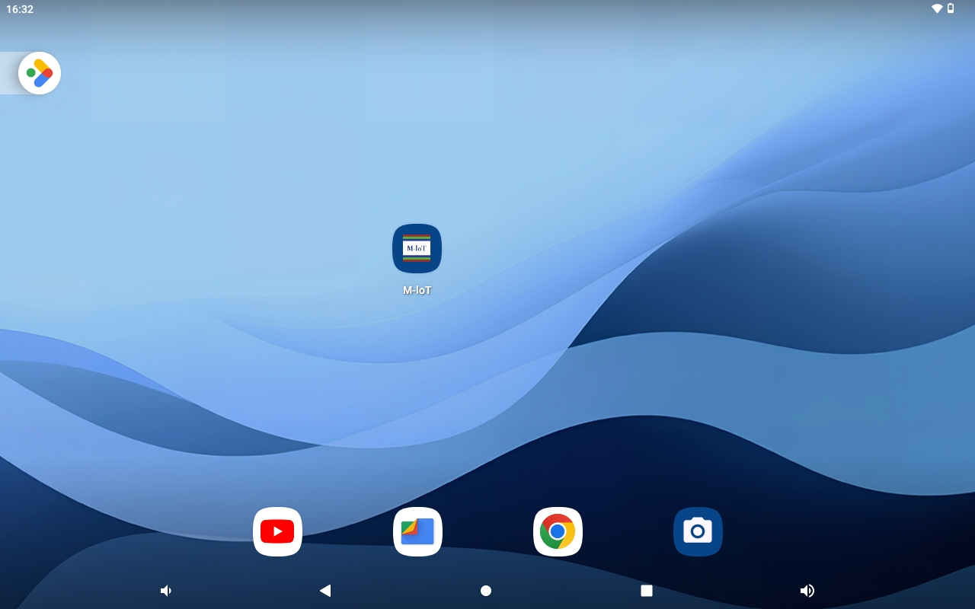
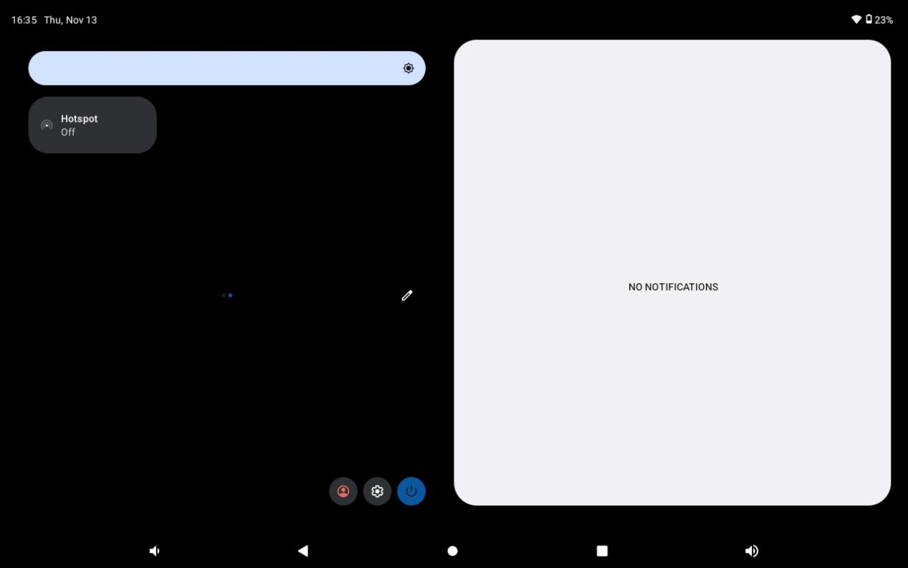
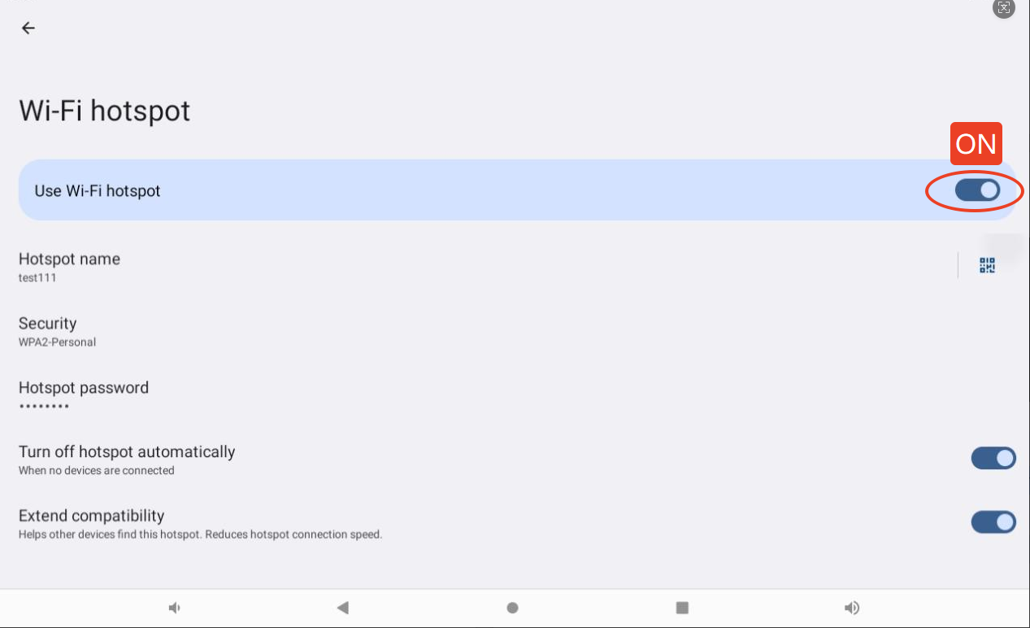

(2) View the hotspot name and password (e.g., name: test111, password: 88888888) .Hotspot name and Passwords can be changed.
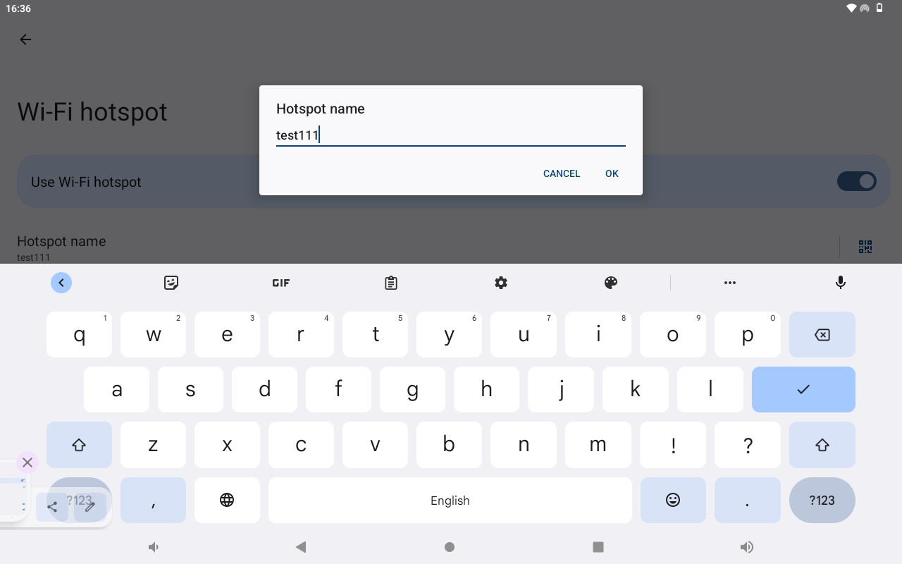
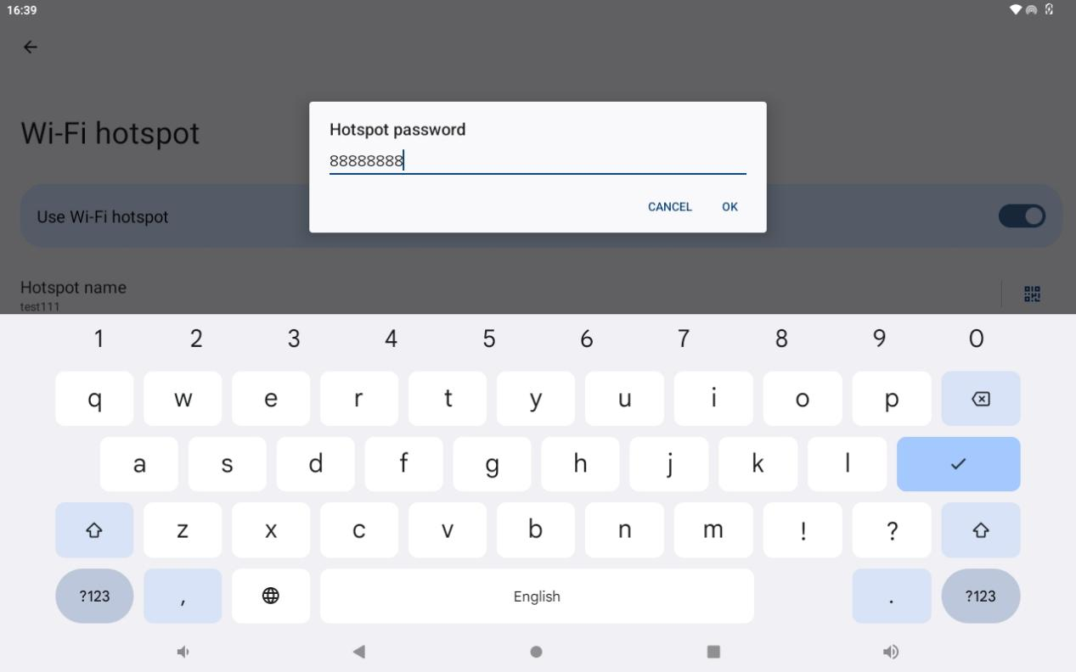

(3) Return to the machine system and connect to WIFI.
Click the "Setting" button on the main page to enter the WIFI settings page.
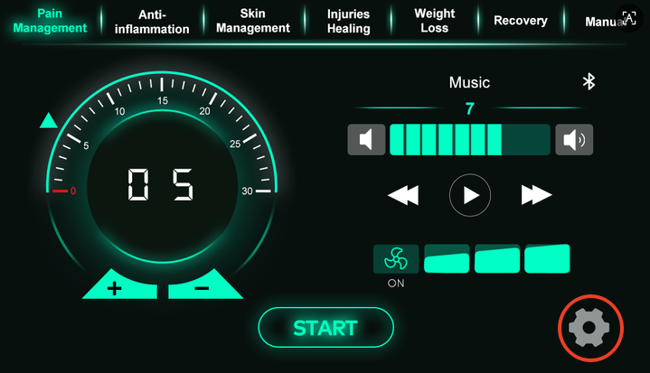

Click the Net name edit box,find and select the tablet/phone's hotspot name. (Name: test111)
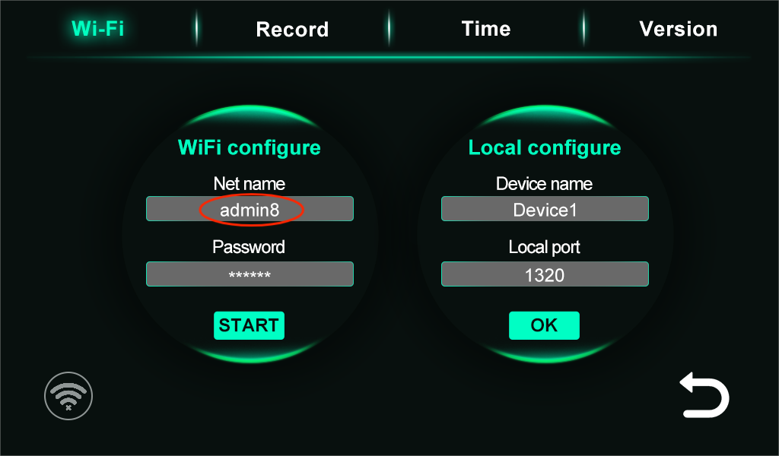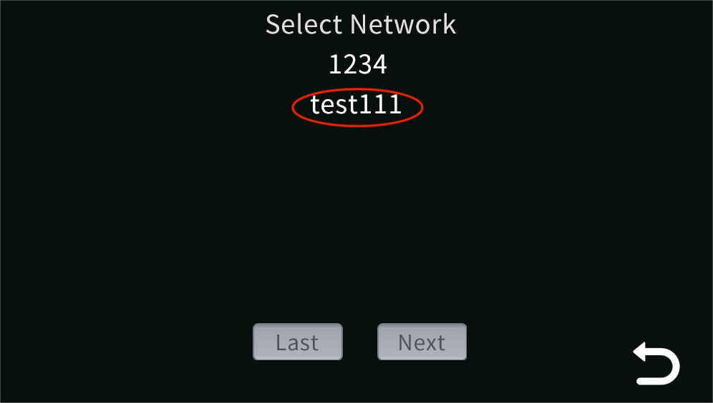
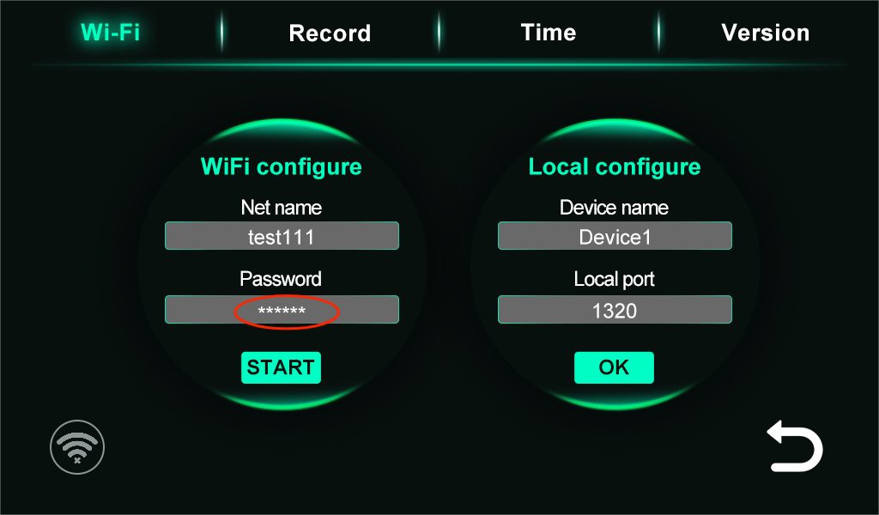
Click to enter the tablet/phone hotspot password (password: 88888888)
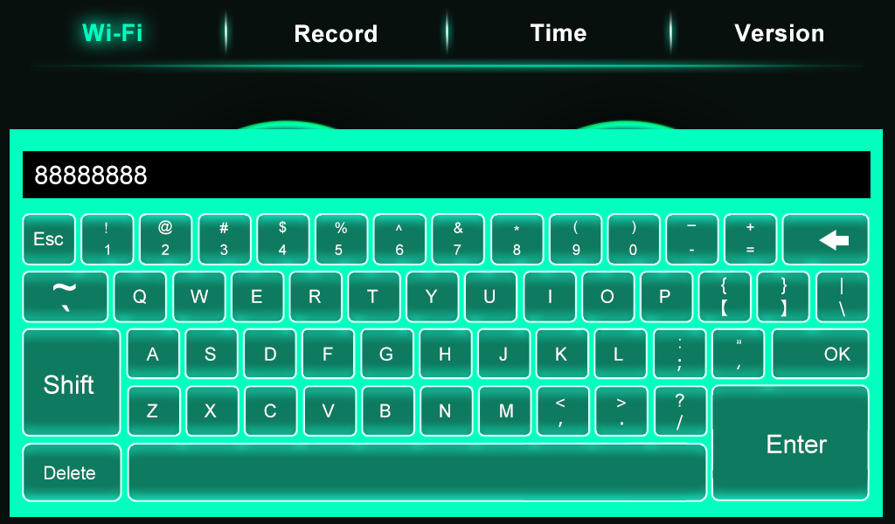
After entering the name and password, click START. The machine will attempt to connect to the WIFI. The connection status will be displayed in the red area in the image below .
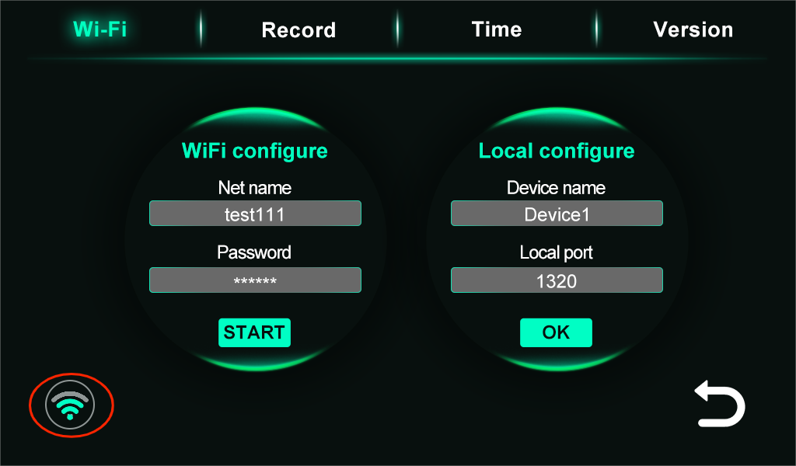
Open the app on your tablet and check if the device is connected . If the app displays the machine name, the connection is successful. If the connection is unsuccessful, please exit the app and reopen it.

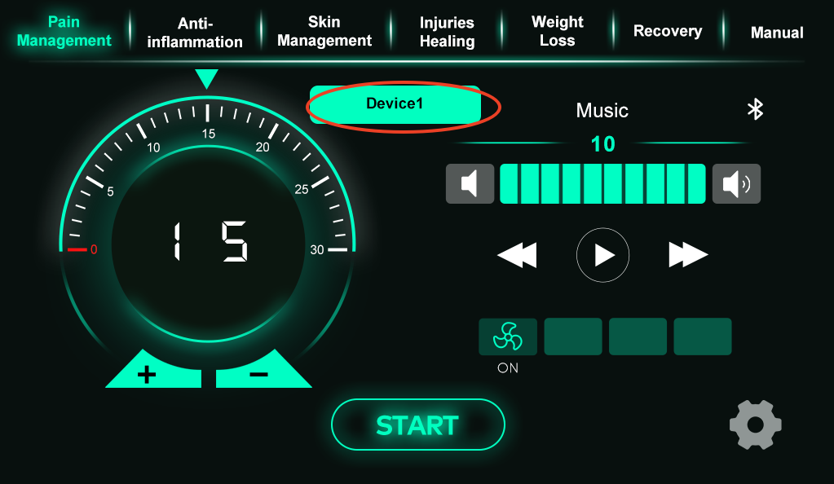

3.10 Screen saver.
After 5 minutes of inactivity, the screen brightness decreases, but the running status remains unchanged. After 10 minutes of inactivity, the screen saver (black screen) is activated. If the screen is in paused mode, it will terminate by default. The screen saver will not activate while the screen is running. Touch the screen to exit the screen saver mode after it has been activated.

3.11 System alarm.
When a system alarm occurs, the alarm message will be displayed in red at the bottom center of the main page, and a buzzer will sound once per second for 0.5 seconds each time . The system has a total of two alarm messages, the content of which and their meanings are as follows:
- When the system is not connected to the output control board, the system will display the alarm message " Failed to connect the output control board!" . If this alarm occurs, please contact the supplier immediately for assistance.
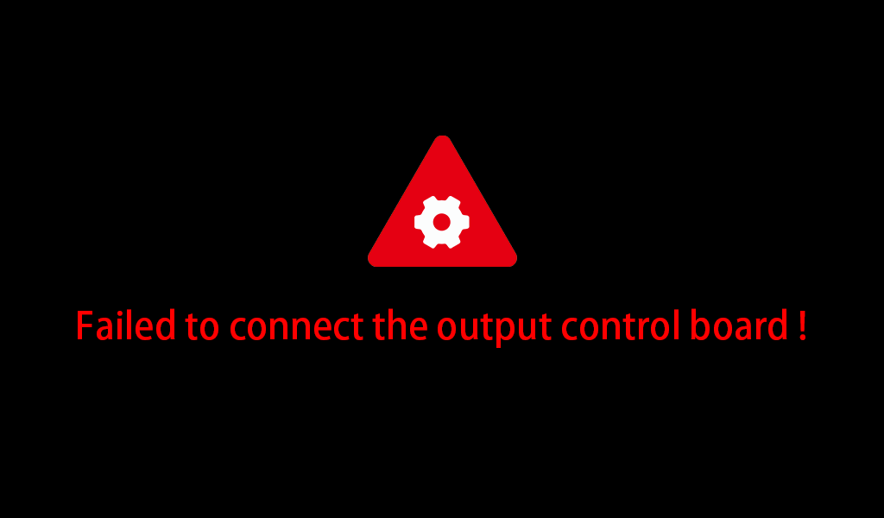
- The system will display an "Excess temperature of the machine!" alarm message if it detects that the temperature from one of the two temperature sensors has reached or exceeded the system's set overheat alarm temperature , or if both temperature sensors are not properly connected. If this alarm occurs, please immediately shut down the machine and allow it to cool down. If the alarm message persists after the temperature has decreased, please contact the supplier for assistance.(When the temperature exceeds the alarm temperature by 5 degrees Celsius, the lights will automatically turn off and the system will be unable to operate. Cooling is required. The machine can only be operated normally when the temperature drops below the alarm temperature by 5 degrees Celsius.)

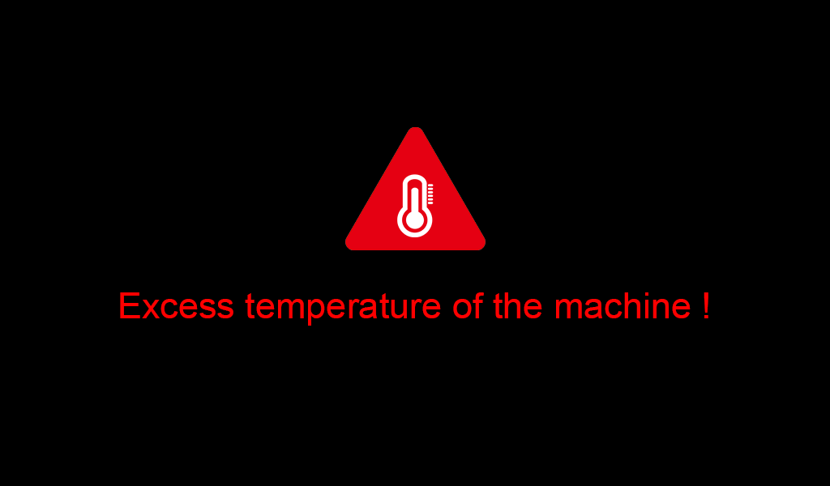

3.12 Notes for Machine Use
- When the machine is not in use, the machine door should be kept open and the plug should be unplugged;
- When maintaining or cleaning the interior of the bed, ensure that the power supply is disconnected, and do not use liquid to clean the live parts;
- If the wire is damaged, it must be replaced by the manufacturer/service agent/related professionals to avoid injury;
- The organic glass plate in the engine room is damaged, cracked or scratched, please replace it immediately;
- After each use, use hypochlorous acid disinfection water/75% alcohol to clean the transparent acrylic in the bench; clean the whole machine once a week;
- When the machine is in the standby state, it is strictly forbidden to touch or lie on the instrument with water, and it is strictly prohibited to clean the machine stains in the standby state.

Faults and troubleshooting
The following failures may be encountered during use, please refer to the following methods for simple failure analysis:

No Display after Power On
Use a multimeter to check whether the input power voltage of the machine is normal.

The power air switch trips after power-on
Check whether there is a grounding or short circuit between the input power supplies, and eliminate the problem.

The display is normal after power on, but the led light does not work
- Check whether the light interfaces is loose;
- Check whether the driver is burned out, if so, please seeks service.

Maintenance and Inspection

Daily Maintenance
In order to prevent the machine from malfunctioning, to ensure the normal operation of the machine, and to extend the service life of the machine, daily maintenance of the machine is required. The contents of the daily maintenance are as follows:
Check Item | Content
Environment Temperature | Confirm the ambient temperature is between 15°C and 35°C
Humidity | Confirm that the relative humidity of the environment is ≦75%RH and there is no condensation
Oil mist and dust | Check that there is no oil mist, dust, or condensation in the machine
Machine | Check whether the machine has abnormal heat and vibration
Fan | Confirm that the fan is running normally and no debris is stuck, etc.
Input power | Check whether the input power voltage is normal

Regular Maintenance
In order to prevent the machine from malfunctioning and ensure its long-term high-performance and stable operation, the user must check the machine regularly (within half a year). The inspection contents are as follows:
Check item | Check content | Method of exclusion
Nut Screw Interface | Is The Nut Loose? | Tighten
Body | Dust, Dirt | Wipe clean with hypochlorous acid disinfectant.
Fan | Abnormal Noise And Vibration | 1) Remove Debris  2) Replace The Fan
Air Inlet/Air Inlet | Dust And Dirt | Use Dry Compressed Air To Completely Remove Debris
Light Strip | Light Strip Does Not Light | Ensure the light is opened, try switching wavelength.  Contact Us To Guide to Check whether the connecter is loosened.
Wires And Their Interfaces | Whether It Is Damaged Or Loose | Contact Us To Guide Replacement

Storage
The LED therapy bed must be placed in its packaging box before installation. If the machine is not in use temporarily, in order to make the machine meet the company's warranty and future maintenance, please refer to the following precautions for storage:
- The storage must be placed in a dust-free, dry environment;
- The ambient temperature of the storage location must be within the range of 15°C~35°C;
- The relative humidity of the storage location must be 0%~75%RH, and there should be no condensation;
- The storage location should avoid corrosive gases and liquids;
- There should be proper packaging protection, and should be stored above the ground.

Product Warranty

Warranty Description
- During the warranty period, for any faults caused by product quality, the Merican after-sales service center will send replace parts free of charge,then user arrange professional electrician to replace it;
- Since the date of receipt of the machine,five year warranty for the whole machine/accessories will be provided(no human damage), and the accessories will be replaced free of charge within five year; after the warranty period, life-long maintenance (repair fees will be charged according to the regulations), otherwise agreed in accordance with the agreement;
- If users have special requirements for services, they can consult with the after-sales service center of Merican;
- The relevant technical data of this machine can be provided to the technical service personnel authorized by our company when necessary.

Not Included In the Free Warranty Service
- More than five year from the date of receipt of the machine;
- Failure caused by unauthorized disassembly or modification of the machine;
- Damage caused by non-professional installation, maintenance and assembly;
- Damage caused by using non-original parts or inferior parts;
- Failure caused by accidental beating or falling during use and handling;
- Failure caused by lack of reasonable maintenance or failing to meet environmental requirements;
- Failure caused by incorrect operation not in accordance with the requirements of the instruction manual;
- Damage to machines and accessories caused by man-made causes;
- Failure caused by self-maintenance without our company's permission;
- Machine failure caused by unstable local voltage;
- Failure or damage caused by force majeure such as fire and earthquake.
For products not covered by the warranty, our company provides paid maintenance services, and the same performance problem will enjoy a free warranty period of 3 months from the date of repair.

Product Number
Sale Date
User Profile | User Name
User Profile | Mailing Address
User Profile | Contact Number
User Profile | E-Mail
Repair Date | Repair Record |  | Remarks

Contact Us
If you need to order products or have any questions, you can contact us in the following ways:
Company: GUANGZHOU MERICAN OPTOELECTRONIC TECHNOLOGY CO.,LTD
Address: Building A, Yimei Industrial District, No.8 Fuyuan 3rd Road, Jinghu Street, Huadu District, Guangzhou
Website: www.mericanholding.com

